

**Who is eligible?**

HOPES

Helping Our Newcomers Prepare for Employment Success



This program will benefit newcomers who:

* are struggling to find employment appropriate to   
  their education, skills, and experience; or want to develop their own business
* need individual support for resettlement stress
* are looking for personal and organizational  
  connections within the community
* have job-ready English communication skills (CLB 5 +)
* are able to commit time to each component of the program to work towards their goals
* are permanent resident, conventional refugee, citizen or refugee claimant

Workshops are limited to 2o participants.



Redefine your career, employment goals and /or explore entrepreneurship options within a new cultural context and take your first steps forward!

Take advantage of ongoing counselling   
and support from employment agencies   
and programs.

Integrate successfully into the workforce.

Do you feel discouraged & confused about your career development, and employment prospects in Canada? Join us for this unique employment program & learn how to:

Building Strengths for Work

It’s FREE for eligible participants! TTC tokens & light

refreshments will be provided for the Group Workshops.

**What is the cost?**

**INDIVIDUAL COUNSELLING**

**Manage Culture Shock and Know Yourself**

Learn to recognize signs of confusion, disorientation,   
& unease to better adjust to your new surroundings.

Discover how you manage transitions & identify personal qualities to support adapting to changing circumstances.

**Decrease Stress &**

**Increase Hope**

Develop emotional & behavioural strategies to address stressors & develop

a positive outlook on challenges ahead.

**GROUP WORKSHOPS**

**Clarify your Goals**

Redefine your employment goals based on your strengths & talents, & identify barriers & areas for further development. Understand your values & beliefs, & identify your ideal work environment.

**Design your Action Plan**

Learn planning strategies & identify resources to implement your plan for successful integration in the Ontario economy toward employment and financial security.

**Build Empowerment**

Bring ownership to your job search & feel empowered to get the job

you want.

**How does HOPES work?**

Designed especially for newcomers, the program   
flows through 3 phases adapted to your needs:

Counselling: MNLCT offices

Workshops: TBD

Employment Coaching: MNLCT & partner agencies in the GTA

**Where is HOPES?**

Contact **Ines** at (647) 776-2057 x 304   
or [Ianderson@mnlct.org](mailto:Ianderson@mnlct.org) for your  
 intake interview!

**How can I participate in HOPES?**

**EMPLOYMENT AGENCY CONNECTIONS & COACHING**

**Make Community Connections**

Get support to continue with your job plan. Be referred to organizations & programs in the community that can help you advance toward employment.

**Stay Focused**

Take advantage of continued career advice & emotional support to stay motivated  
& execute your action plan.

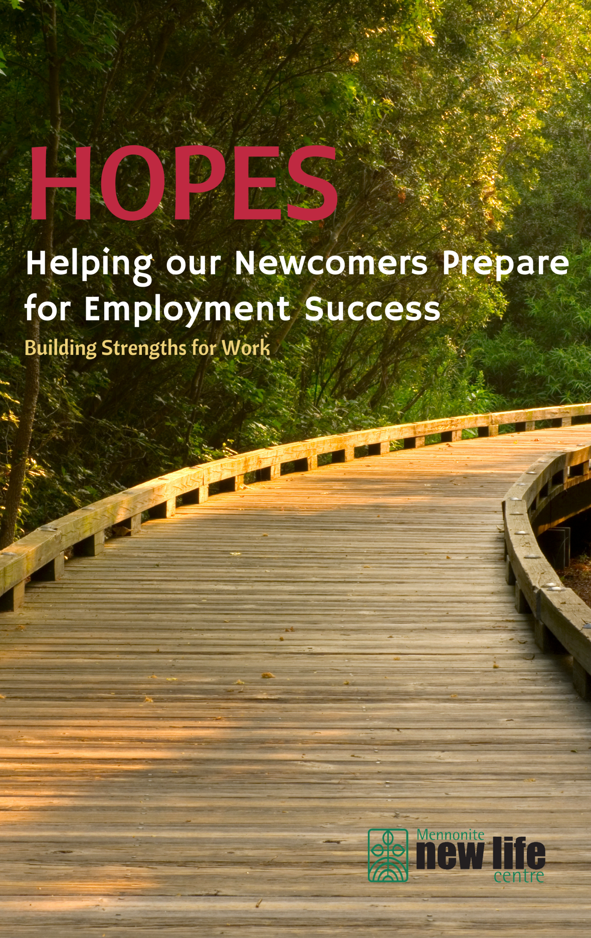

The **Mennonite New Life Centre of Toronto** is a settlement agency founded in 1983. Its mission is to facilitate newcomer settlement and integration through holistic services and community engagement, carried out within a gender justice and anti-oppression framework.

We offer programs in the areas of settlement, employment, language instruction, community engagement and community mental health.

***Building Strengths for Work*** is an initiative of the Community Mental Health Program. Our goal is to provide emotional support to newcomers struggling with stress or trauma, and promote resilience, strength and well-being at the individual and community level. We work in partnership with community groups to make services available to all newcomers.



This program is funded by United Way Greater Toronto.

***Contact us now for more information***

1774 Queen St East, **Toronto**, ON M4L 1G7

416-699-4527 | mnlct@mnlct.org

3570 Victoria Park Ave Suite 204, **North York**, ON M1H 3S2

416-291-3248 | victoriapark@mnlct.org

2737 Keele St Unit 9, **North York**, ON M3M 2E9

647-776-2057 | keele@mnlct.org

[www.mnlct.org](http://www.mnlct.org) | facebook.com/MNLCT | twitter.com/MNLCT